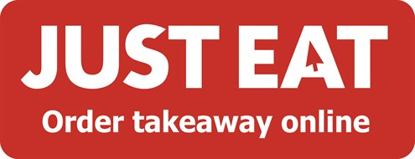

JUST EAT ANNOUNCES EXCITING SPONOSRSHIP OF TASTE OF DUBLIN

May 2015 – JUSTEAT.ie, Ireland’s leading online takeaway brand has announced that it has teamed up with Taste of Dublin, as a Sponsor for 2015. For the first time ever, JUST EAT will be providing an exclusive waiter service at the Taste of Dublin Festival, which is taking place from the 11-14 June in Iveagh Gardens.

Those attending will be able to spend more time exploring and less time queueing with JUST EAT waiters on hand who will take attendees florins and queue for food and drinks on your behalf making the festival an overall more enjoyable experience.

Edel Kinane, Marketing Director at JUST EAT said: “We’re delighted to announce this exciting sponsorship of Taste of Dublin. JUST EAT is all about making life easier for its customers. We recently launched a new lunchtime service, allowing customers to order from their favourite lunch spots online instead of waiting in line. In true JUST EAT style, waiters on site will take your florins and queue for food on your behalf, delivering it back to you faster than you can say #minifistpump!”

ENDS

